**Simulation of ODE using Simulink**

**Lab report #06**



Fall 2022

CSE-310L Control Systems

Submitted by: **Ashfaq Ahmad**

Registration No: **19PWCSE1795**

Class Section: **B**

“On my honor, as student of University of Engineering and Technology, I have neither given nor received unauthorized assistance on this academic work.”

Student Signature: ______________

Submitted to:

**Dr: Muniba Ashfaq**

**Nov** 10, 2022

**Department of Computer Systems Engineering**

**University of Engineering and Technology, Peshawar**

**Task01:** Solve the following ordinary differential equation using Simulink.

**y’’+y2y’-y’+y=0**

**y’(0)=0, y’’(0)=12**

Block diagram:

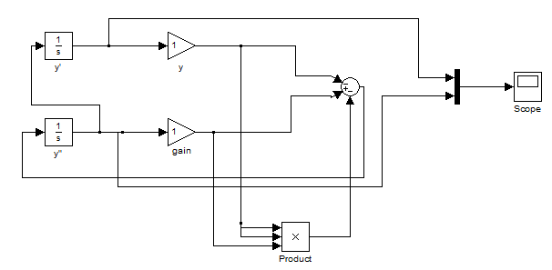

Plot:

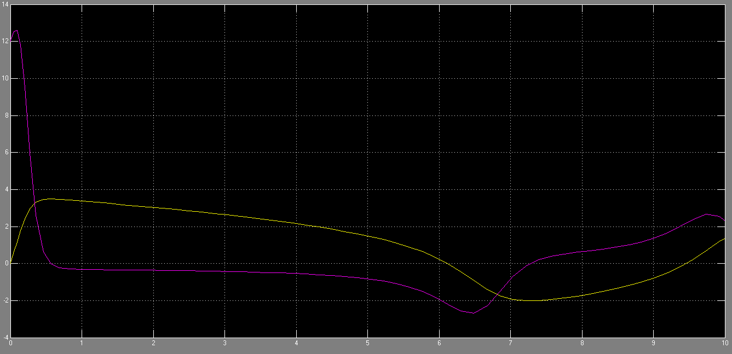

**Task02**: Solve the following ordinary differential equation.

**yv+2yiv +24y’’’+48y’’+24y’ +20y+10=0**

**y(0)=2, y’(0)=5, y’’(0)=10, y’’’(0)= - 4, yiv(0)= -7**

Block diagram:

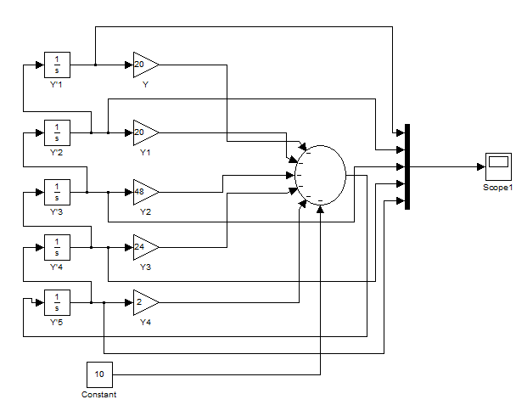

Plot:

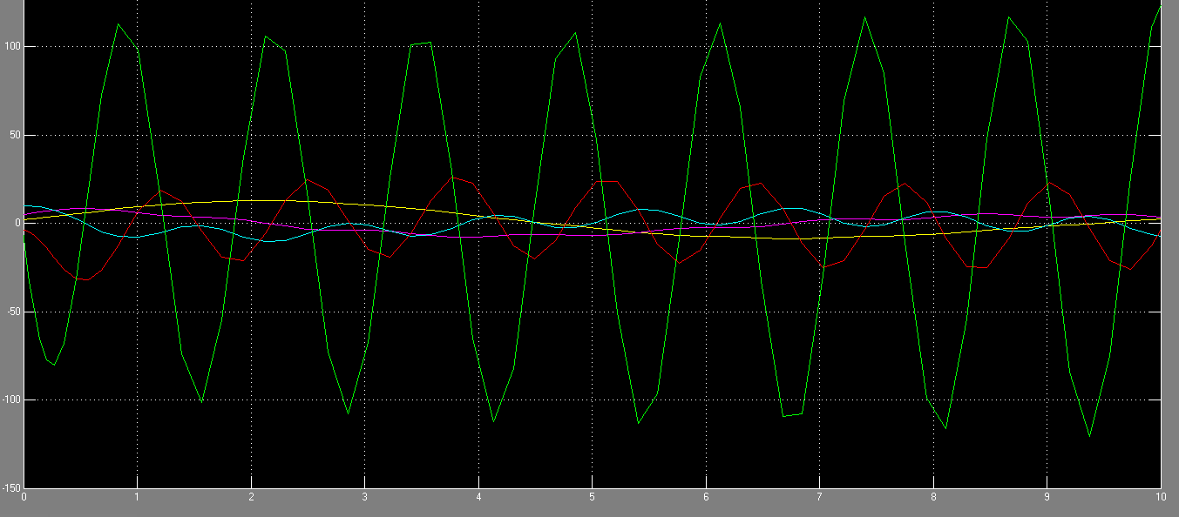

**Task03**: Solve the following ordinary differential equation using Simulink.

**yiv +16y’’’-8y’’+y’ +6y=0**

**y(0)=4, y’(0)=0, y’’(0)= -6, y’’’(0)= 2**

**Block diagram:**

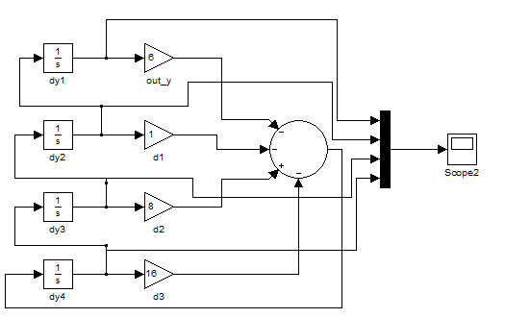

**Plot:**

